Newton County, Texas: Disaster Recovery Needs Assessment
Section 1: Introduction
Newton County is located in southeastern Texas along its border with Louisiana. The County’s eastern border is demarcated by the Sabine River at the Toledo River Bend Reservoir spillway. The Sabine River watershed completely encompasses Newton County’s 940 square mile jurisdiction. Elevations across this largely rural landscape range from near 599 feet above sea level in the northwestern portions of the County to less than 99 feet in the southern portion, and where most of the population resides.
Many areas of the County were inundated with historic flash and river flooding in 2015 and 2016, impacting housing, infrastructure, and other vital economic resources. These disasters were included in three Presidential Declarations: DR-4223 declared May 29, 2015, DR-4245 declared November 25, 2015 and DR-4266 declared March 19, 2016.
The first event, now called the “Memorial Day Floods,” occurred overnight on May 23rd and early May 24th. May 2015 has been documented by the National Weather Service as the wettest month in Texas history, with well above-normal rainfall during the first two to the three weeks of the month. A persistent area of low pressure over the western United States brought multiple rain events throughout the month of May that saturated soil throughout south-central Texas. By the time Memorial Day weekend arrived, much of the region was at least 2-4 inches (100-300%) above normal. These wet antecedent conditions meant that any new rain, and especially heavy rain, would become rapid run-off directly into rivers, streams, and flash flood prone areas.
The second flood event followed just six months later in October 2015, referred to as the “All Saints Day flood.” A number of weather factors, including wet antecedent conditions, came together across southcentral and east Texas to produce intense rainfall in excess of ten inches in Newton County, causing the Sabine River to once again swell beyond its banks with consequent flooding.
Finally, less than a year after the Memorial Day flooding event, the Sabine River crested at its highest level in over 130 years due to rainfall in the basin totaling over eighteen inches during a five-day period in March 2016. With the weather system lingering over the area, the previous high-water record set in 1884 was surpassed by over a foot. More than 400 homes were flooded, and mandatory evacuations were required for this one major event.
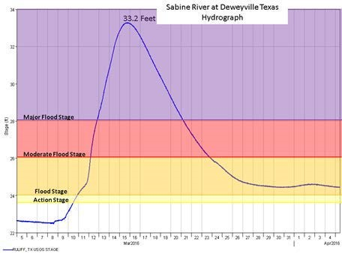
Funding from the U.S. Department of Housing and Urban Development (HUD) is being accessed through the Texas General Land Office in the form of Community Development Block Grant Disaster Recovery (CDBG-DR) assistance with ongoing recovery needs. These funds are to be utilized for recovery work in the most impacted and distressed areas of Newton County, or in other areas that will provide benefit to the LMI populations as required in the 2015 and 2016 disaster declarations and authorized under Title IV of the Robert T. Stafford Disaster Relief and Emergency Assistance Act (42.U.S.C. 5121 et seq.). Pursuant to this Act, CDBG-DR funds may only be used for disaster related purposes.
To assist in its allocation of these funds, Newton County has drafted an Unmet Needs Assessment to quantify the funding needed to repair damages and recuperate losses, factoring in the funds already received by the Federal Emergency Management Agency (FEMA) grants, U. S. Small Business Administration (SBA) loans, insurance proceeds from the National Flood Insurance Program (NFIP), other CDBG funds and other funding sources available. This Unmet Needs Assessment also assists in prioritizing funds by type and location based on concentration of damage and community needs, with particular focus on low and moderate-income areas, households with special needs and displaced populations. This Unmet Needs Assessment has not yet factored in all appropriate resiliency measures worthy of consideration in order to avoid future repetitive losses.
HUD requires that the Needs Assessment evaluate the three core aspects of recovery – housing (interim and permanent, owner, rental, single-family and multi-family, affordable and market rate), infrastructure, and the economy (e.g., estimated job losses or tax revenue loss due to the disaster). By understanding where its critical needs lie, the County will be able to more effectively allocate the available funds. The County recognizes that there is still data missing from these calculations and therefore cautions that this is an estimate of need, not a statement of fact. Information regarding NFIP payout amounts, FEMA Public Assistance payment amounts, unidentified disaster impacted projects, and more will be continually coming in, will need to be reviewed and then incorporated into future revisions of this Needs Assessment. Finally, the County also wants to note that $5,000,000 of the current allocation of $35,370,121 has been allocated to the Deweyville Independent School District (ISD), whose application will be independent of the County’s housing and infrastructure applications.
Section 2:
Housing Resources

A) Prior to Flooding
- Baseline Information
According to the 2010 Census, there were 14,445 residents in Newton County with a median age of 40.7 years. By 2016, the ACS estimated the population at 14,138 residents with no change in median age.
The 2010 census reported 7,142 housing units in Newton County. Of these, 5,476 were occupied housing units, with 83.8% of those being owner-occupied units. A total of 83.2% of residents have lived in their home for seven or more years. 68% of total housing units were more than thirty years old.
Additional census data (2016) is pending evaluation.
- Race and Housing Choices
According to the 2016 ACS the residents of Newton County were primarily White (76.9% of total) and African American (21.1% of total). The two races combined made up 98% of the population. According to the 2010 Census 80.3% of the owner-occupied housing units were owned by whites and 17.3% are owned by African Americans. While 73.5 % of the rental units are were occupied by whites, and 19.9 % occupied by African Americans.
Additional census data (2016) is pending evaluation.
- Disabled Households
According to the 2015 ACS 5-Year Estimate Data, approximately one in three residents of Newton County was over the age of 65 years. Additionally, approximately one in five residents had a disability. Based on 2015 ACS 21.1% of whites and 23.6% of African Americans were disabled.
- Increased Risk of Homelessness
Based on 2010-2014 Comprehensive Housing Affordability Strategy (CHAS) data, 250 owners and 25 renters had a cost burden greater than 50%. A cost burden this high combined with damage to their homes placed these households in imminent threat of homelessness.
- Pre-flood Sources of Housing Funds
Newton County has previously participated in the HOME program offered by Texas Department of Housing and Community Affairs (TDHCA). This is the only assistance the county has been able to provide to their low-income citizens.
- Additional Sources of Funding
Immediately following each disaster event, the County coordinated with numerous organizations, including the Red Cross, FEMA and neighboring counties to provide temporary shelter and other emergency aid to residents impacted by the storms. There are no other ongoing sources of financial assistance for the area.
- Conclusion
Prior to the disasters, the majority of residents in Newton County owned their own homes. Rental units in the county are limited, primarily a result of the large percentage of owner occupied units. The remainder of this section will discuss post-disaster unmet needs and provide recommendations on the allocation of CDBG-DR funding.
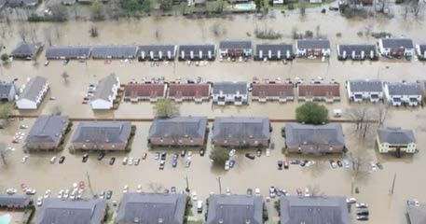

B) After the Flooding
- Damage and Areas of Greatest Impact
The majority of damage occurred in the Sabine River basin and adjacent flood plains. While the communities of Bon Weir in the northern portion of the County and Deweyville in the southern portion of the County suffered the greatest concentrations of damage due to population densities, residents throughout the County were affected.
- FEMA Damage Assessment
One of the largest and most important tasks of disaster recovery is identifying, documenting, and reporting the costs of all damages incurred by the disaster event. Immediately following a disaster, resources are scarce, and expediency and timeliness are critical. FEMA performs damage assessments across the impacted areas to support grant assistance provided through the Stafford Act programs. Newton County received Public Assistance (PA) grants under DR- 4233 for the 2015 storm event. Under DR-4266, Newton County received PA grants as well as Individual and Household grants.

HUD Unmet Need Methodology
The method that HUD uses to determine Unmet Need is described in great detail in the Federal Register. Unmet Need, at its very basic level, is defined as that amount of funds necessary to make the County whole again following a disaster. Unmet Need also takes into account the amount of funds and resources that an entity has already received from other external sources such as FEMA, NFIP or the SBA, as well as any other sources of funds that the entity might have that could be directed to help solve these needs. Finally, no responsible jurisdiction would consider an Unmet Needs Assessment complete without discussing the cost of completing activities that will keep the County from incurring this same type of damage in the future. Unfortunately, this number is very hard to quantify, so as a result, unless a project has recently been studied or engineered, knowing exactly what “cost” mitigation activities will add to the formula of unmet need is very difficult to determine.
However, for the purposes of this Needs Assessment, Newton County will use the following HUD established methodology to determine the remaining unmet need under Housing as well as the other categories of Infrastructure and Economic Development.
HUD has published guidance documents for the establishment of Unmet Housing Needs as Appendix A attached to the Federal Register authorizing this allocation (published June 9, 2016). According to this guidance, HUD uses the following methodology for estimating unmet needs. The following information is taken from the Appendix to the Federal Register. It should be noted that this is guidance on how HUD would calculate unmet need; the County will endeavor to follow this guidance as much as the data permits.
The data HUD staff have identified as being available to calculate unmet needs for qualifying disasters come from the following data sources:
- FEMA Individual Assistance program data on housing-unit damage as of __________;• SBA for management of its disaster assistance loan program for housing repair and replacement as of ____________;
- SBA for management of its disaster assistance loan program for business real estate repair and replacement as well as content loss as of ________; and
- FEMA- estimated and -obligated amounts under its Public Assistance program for permanent work, Federal and State cost share as of ____________.
c.
Homelessness

D. Calculating Unmet Housing Need
Unmet Housing Need has been determined utilizing FEMA as well as SBA date in conjunction with input from the citizens of Newton County. Much of this information was obtained through phone logs maintained by the County itself. Of the data maintained by the county: 65% of the flood victims were affected in the floods in 2016 and 2017; an additional 15% were affected by 2015, 2016 and 2017 disasters; 5% were affected by 2016 floods only, whereas 15% were affected by 2017 (Harvey) only; and 5% of all respondents expressed an interest in the buyout program. In addition, data has been gleaned through current HMGP buyout programs related to the disasters. The following table addresses the distribution of available funding based on the identified needs.
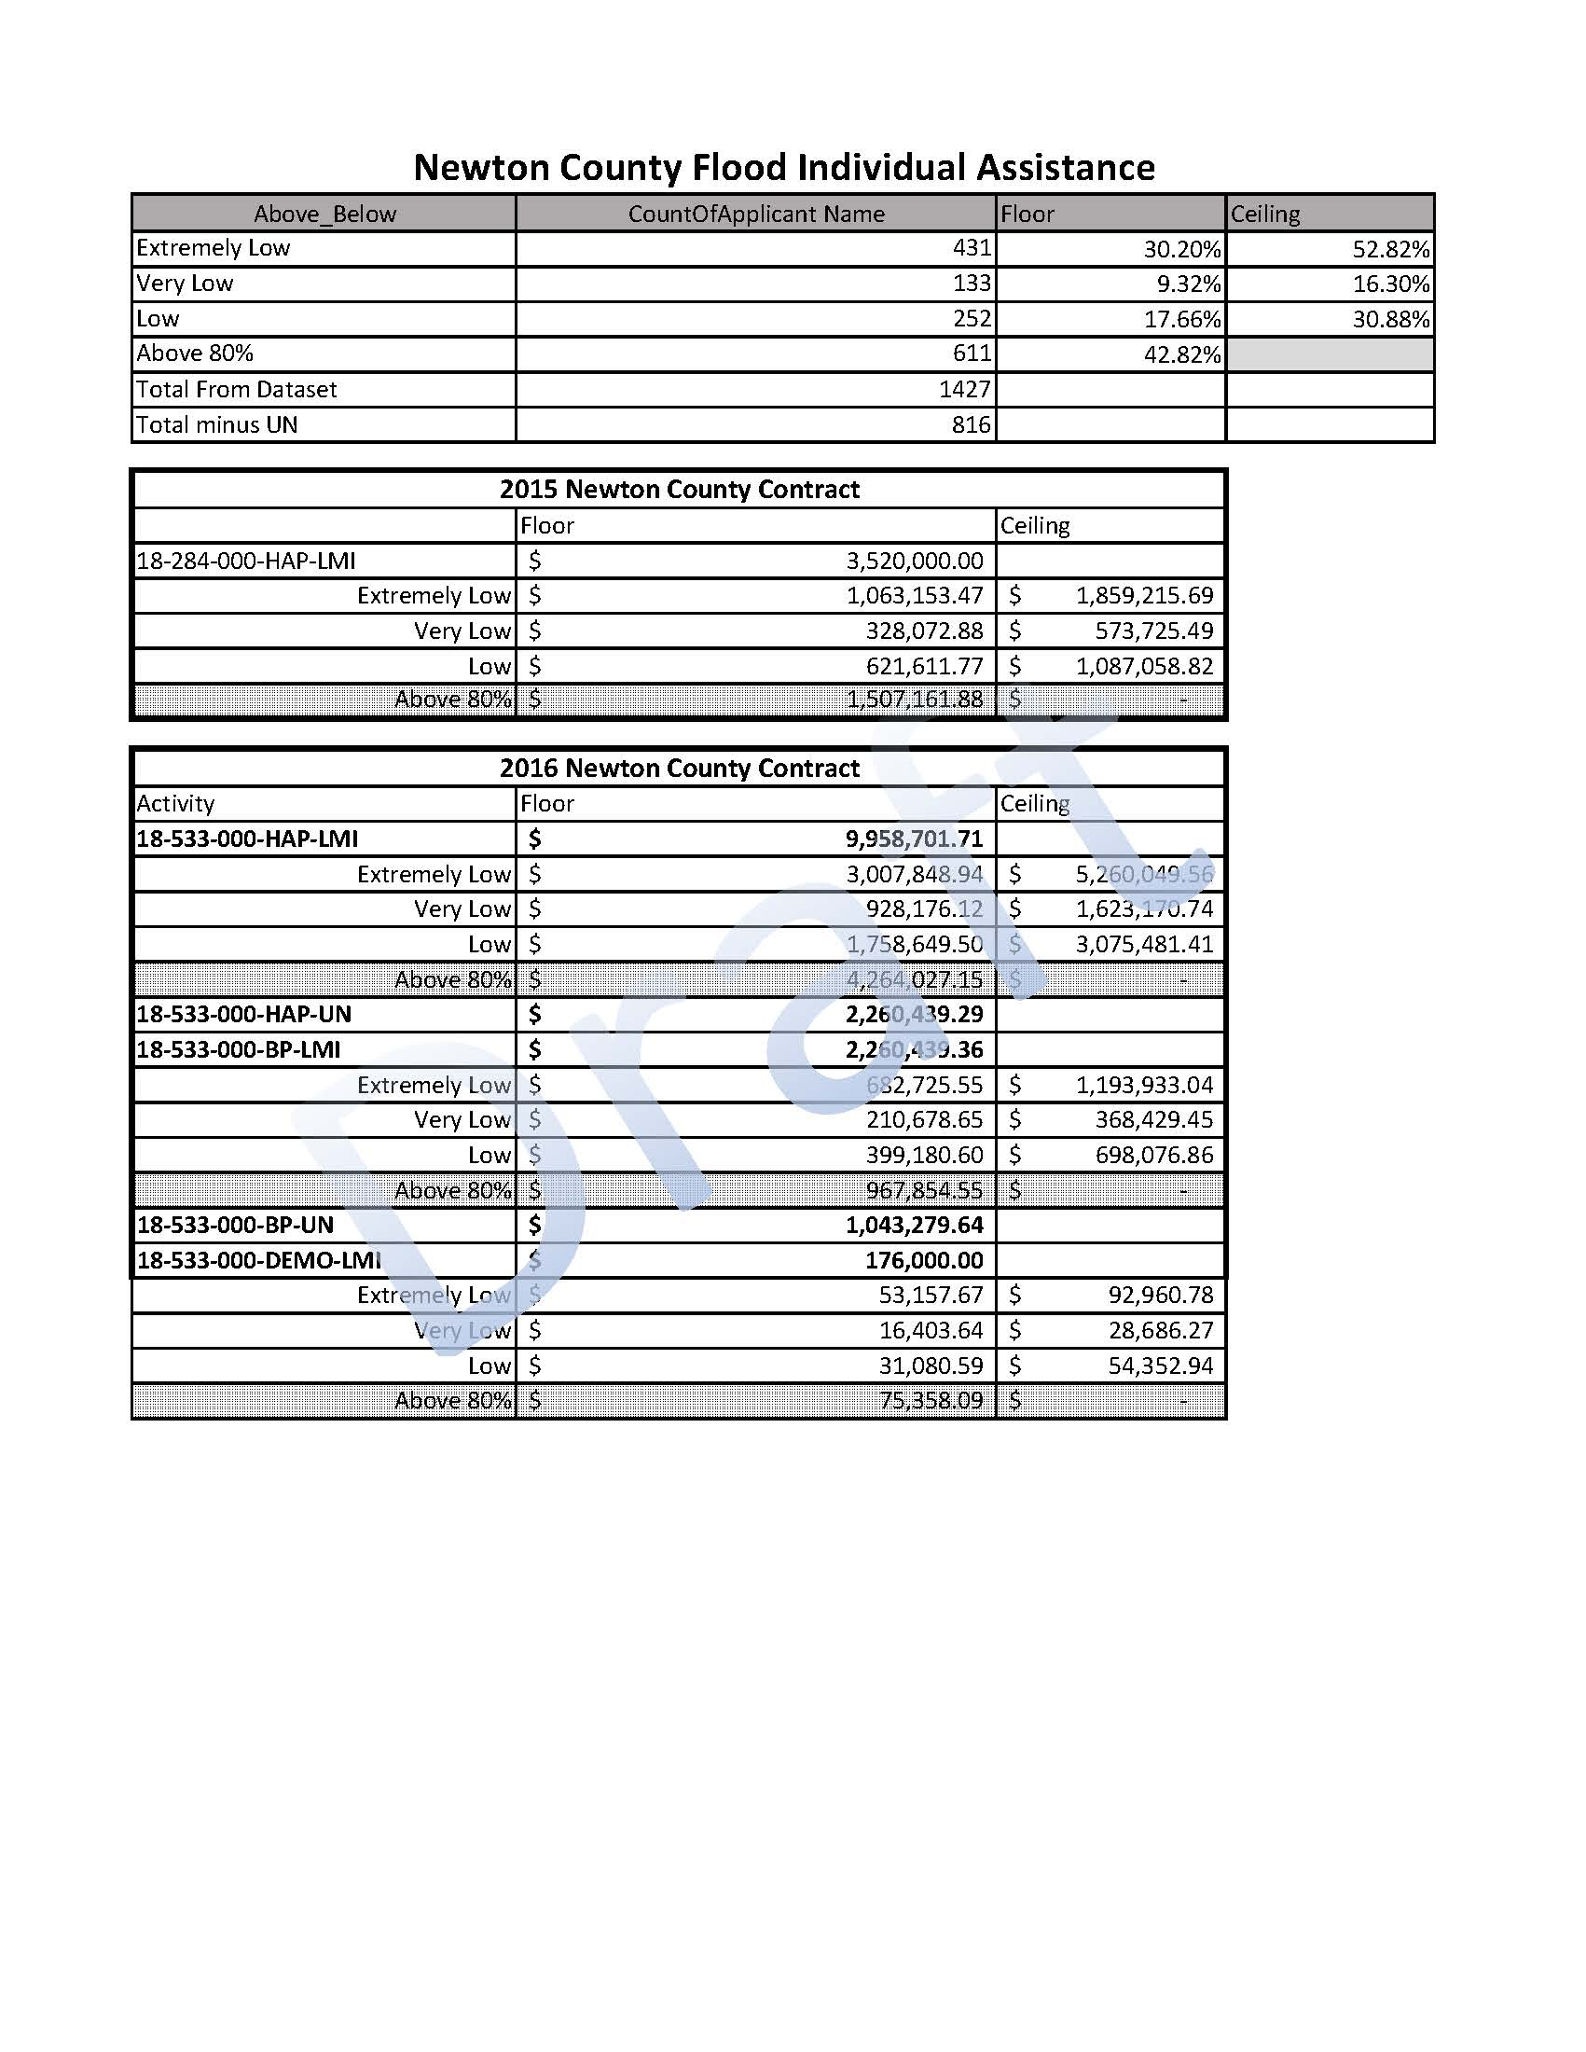

E. Insurance Proceeds
Standard homeowner’s insurance does not cover flooding, however it is important to have protection from the floods associated with hurricanes, tropical storms, heavy rains and other conditions that impact the U.S. FEMA created the National Flood Insurance Program (NFIP) to help provide a means for property owners to financially protect themselves. The NFIP offers flood insurance to homeowners, renters, and business owners if their community participates in the NFIP. Participating communities agree to adopt and enforce ordinances that meet or exceed FEMA requirements to reduce the risk of flooding. To date, NFIP claims have been processed for 86 residential properties. This represents a potential additional $8,154,150 in funding that has been provided to the citizens of Newton County to assist in meeting their flooding recovery and will reduce the overall unmet need for housing.
F. Public and HUD Assisted Housing Needs

a. Other sources of funds
Thanks to the generosity of many of the non-profit organizations that volunteered their time and assistance to victims of these floods, many homeowners have received temporary shelter, damage repair and relocation.
b. Displaced Households
The County does not currently have specific information as to the number of single family property owners that remain displaced throughout the county. Based upon information provided by the Newton Housing Authority, there were no families residing in public housing displaced due to the flooding.
- Homelessness
Due to the unavailability of services or assistance for homeless within Newton County, there are no statistics currently available.

- Hazard Mitigation Activities
  - Newton County has actively sought assistance through the HMGP program. They solicited HMGP buyout funds in both the 2015 and 2016 cycles.

- Housing Sector Conclusion and Summary
  - The housing needs in Newton County center around getting homeowners back into safe, sanitary living conditions and to prevent continued damage from future flooding. Though few units are lacking plumbing or kitchen facilities, there is a need for minor to moderate housing rehabilitation to prevent further deterioration as well as a need to demolish and reconstruct unsafe/unsound housing. Rehabilitation, reconstruction and/or elevation will allow homeowners to once again occupy their existing single-family homes damaged by the floods. New construction activities will allow property owners whose homes were destroyed to rebuild. Buyout programs will compensate owners for their losses and assist with relocation.

Section 3: Infrastructure Resources
Infrastructure resources were impacted by these major flooding events. Principally impacted were those public roads in flat and low-lying areas as well as those road sections adjacent to overwhelmed drainage structures. County-wide, the residential neighborhoods are drained naturally or via culverts, even in many of the more urbanized areas such as Deweyville. The drainage capacity of these older structures was exceeded in these intense rainfall events.

Section 4: Economic Resources
- There are no known commercial or Agricultural resources available to Newton county at this time to assist in recovery.

Section 5: References
2010 U.S. Census Data
2016 American Community Survey Data
FEMA Individual Assistance Data

Section 6: Attachments
Figure 1: County-wide Distribution of FEMA Applications (Census Block Groups and Flood Zones)
Figure 2: County-wide Distribution of FEMA Applications and Elevation Ranges
Figure 3: County-wide Population Distribution in 2010 (pending 2016 comparison)
Pending: County-wide Household Income Distribution

Attachment B: Tables Newton County Low-to Moderate Income Analysis (2011-2014)

County | Population | Percentage
Under 30% | 1633 | 12.90%
30% to 50% | 1735 | 13.70%
50% to 80% | 2215 | 17.49%
Avobe 80% | 7079 | 55.91%

Newton
LMIUniv 12662 100.00%
 |  |  |  |  |  |  |  |  |  |  |  |  |  |  |  | 80 |  | 50 |  | 30
PLACENAME |  |  | TRACT |  | BLKGRP |  |  | LOWMOD |  | LOWMODUNIV |  | LOWMODPCT |  | POP100 |  | PMOD | PMOD% | PLOW | PLOW% | PVLOW | PVLOW%
Newton County |  |  | 950100 |  | 1 |  |  | 154 |  | 530 |  | 29.10 |  | 576 |  | 154 | 13.54 | 76 | 6.08 | 41 | 7.12
Newton County |  |  | 950100 |  | 1 |  |  | 383 |  | 891 |  | 43.00 |  | 876 |  | 383 | 21.80 | 192 | 14.95 | 61 | 6.96
Newton County |  |  | 950100 |  | 2 |  |  | 456 |  | 754 |  | 60.50 |  | 723 |  | 456 | 24.07 | 282 | 19.78 | 139 | 19.23
Newton County |  |  | 950300 |  | 1 |  |  | 850 |  | 1402 |  | 60.60 |  | 1373 |  | 850 | 27.39 | 474 | 16.90 | 242 | 17.63
Newton County |  |  | 950300 |  | 2 |  |  | 676 |  | 1355 |  | 49.90 |  | 1384 |  | 676 | 12.28 | 506 | 15.10 | 297 | 21.46
Newton County |  |  | 950400 |  | 2 |  |  | 395 |  | 1167 |  | 33.80 |  | 1190 |  | 395 | 16.05 | 204 | 9.75 | 88 | 7.39
Newton County |  |  | 950400 |  | 3 |  |  | 0 |  | 0 |  |  |  | 0 |  | 0 | 0.00 | 0 | 0.00 | 0 | 0.00
Newton County |  |  | 950400 |  | 1 |  |  | 450 |  | 1246 |  | 36.10 |  | 1295 |  | 450 | 15.44 | 250 | 11.04 | 107 | 8.26
Newton County |  |  | 950400 |  | 3 |  |  | 427 |  | 1218 |  | 35.10 |  | 1146 |  | 427 | 12.48 | 284 | 9.77 | 172 | 15.01
Newton County |  |  | 950200 |  | 1 |  |  | 539 |  | 1035 |  | 52.10 |  | 1086 |  | 539 | 17.03 | 354 | 14.36 | 198 | 18.23
Newton County |  |  | 950200 |  | 2 |  |  | 21 |  | 37 |  | 56.80 |  | 34 |  | 21 | 26.47 | 12 | 11.76 | 8 | 23.53
Newton County |  |  | 950200 |  | 3 |  |  | 78 |  | 209 |  | 37.30 |  | 186 |  | 78 | 19.89 | 41 | 11.29 | 20 | 10.75
Newton County |  |  | 950200 |  | 4 |  |  | 290 |  | 683 |  | 42.50 |  | 648 |  | 290 | 25.93 | 122 | 9.57 | 60 | 9.26
Newton County |  |  | 950200 |  | 5 |  |  | 453 |  | 1067 |  | 42.50 |  | 1052 |  | 453 | 7.79 | 371 | 17.87 | 183 | 17.40
Newton County |  |  | 950200 |  | 6 |  |  | 411 |  | 1068 |  | 38.50 |  | 1044 |  | 411 | 20.21 | 200 | 17.53 | 17 | 1.63
 |  |  |  |  |  |  |  | 5583 |  | 12662 |  |  |  |  |  | 5583 |  | 3368 |  | 1633
 |  |  |  |  |  | Income Limits
 |  |  |  |  |  |  | NEW 4-PERSON INCOME LIMIT |  |  |  | OLD 4-PERSON INCOME LIMIT
 | TX | 48 |  | Newton County |  | 351 | 11,050 |  | 18,450 | 29,500 | 11,050 | 18,450 | 29,500

